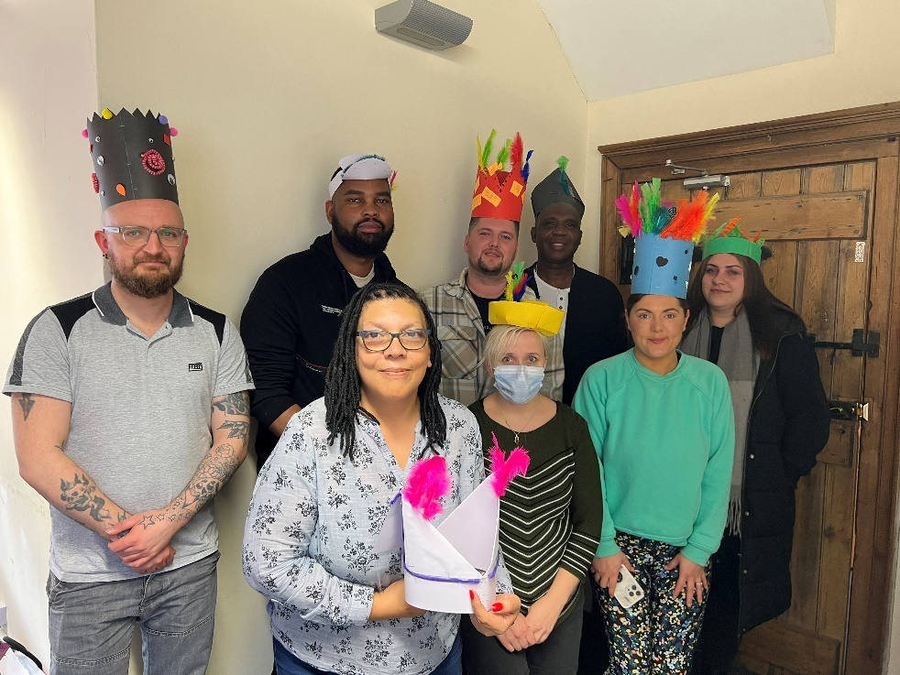

**CTTM Management Development Programme**

We would like to congratulate Dan, Evans, Carl, Ibrahim, Charlotte, Michelle, Danuta and Rhianon on recently completing CTTM’s management development programme.

It was such a pleasure to witness you all grow so much in confidence during the programme and we look forward to watching your continued progress with us.